AI ASSISTED CODING

# AI LAB LAB TEST - 2

## KAVALI SAI KARTHIK

## 2403A52043

BATCH – 3

SUB GROUP N

### Q1. Compute directory sizes from listing

### • Task : Aggregate sizes from a flat listing of `path size` lines so that each parent includes all descendants.

**Prompt:**

Compute directory sizes from a flat listing using a **prefix-walk strategy**, where each parent directory includes the sizes of all its children recursively. For example, input ['/a 10','/a/b 5','/a/c 7'] gives output {'/a':22,'/a/b':5,'/a/c':7}.

**Prefix-Walk Strategy**

The prefix-walk strategy means:

1. For each directory path, split it into parts.
2. Add the given size to the directory itself and to every parent prefix along the path.
3. This ensures that parent folders automatically accumulate the sizes of their children recursively.

### Test Cases

**Test 1:**  
Input: ['/a 10', '/a/b 5', '/a/c 7']  
Output: {'/a': 22, '/a/b': 5, '/a/c': 7}

**Test 2 (Nested):**  
Input: ['/x 4', '/x/y 3', '/x/y/z 2']  
Output: {'/x': 9, '/x/y': 5, '/x/y/z': 2}

**Test 3 (Multiple roots):**  
Input: ['/a 2', '/b 3']  
Output: {'/a': 2, '/b': 3}

*CODE :*

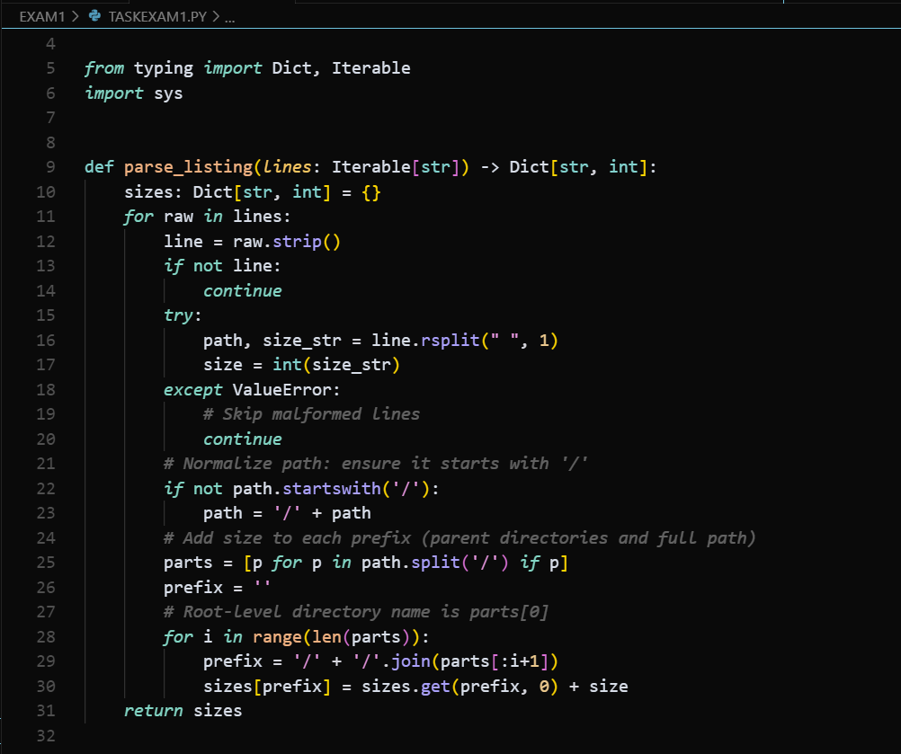

***Observation:***

*The code reads each path size line, adds the size to that path and all its parent folders, and finally returns a dictionary of total sizes.This makes every parent directory show the sum of its own size plus all of its children.  
Example: ['/a 10', '/a/b 5', '/a/c 7'] → {'/a': 22, '/a/b': 5, '/a/c': 7}.*

### Q2. Compute simple sentiment score

Task : Compute total sentiment using: good=+1, great=+2, bad=-1.

Prompt : Write Python code that reads a sentence and calculates a sentiment score.

Use this lexicon: good = +1, great = +2, bad = -1.

Tokenize by spaces, remove basic punctuation, and return the total score as an integer.

CODE : 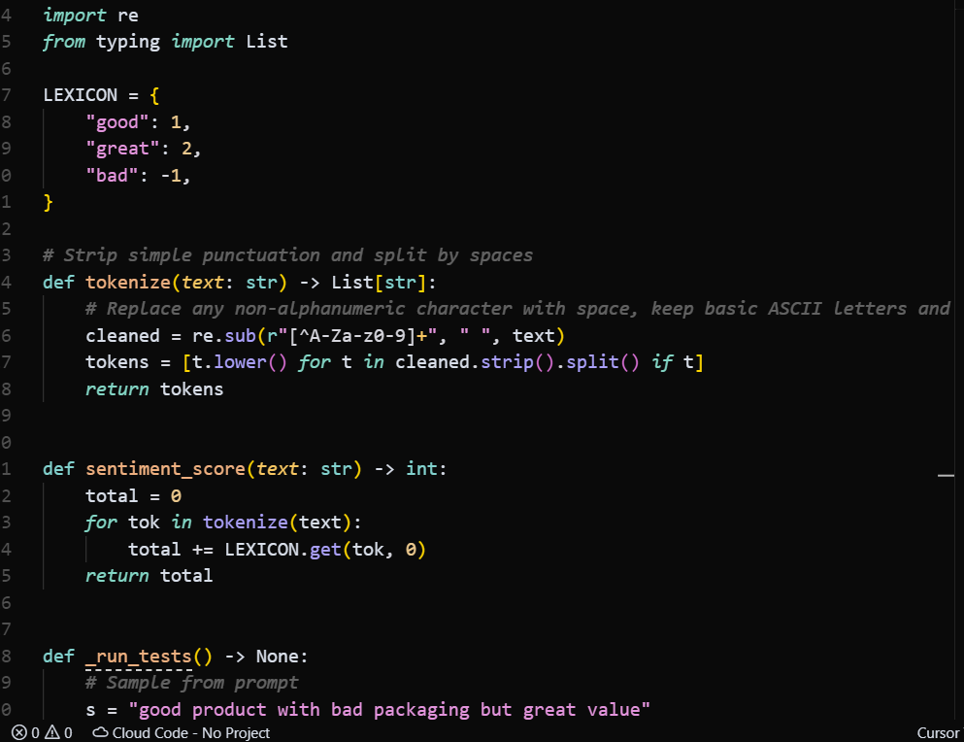

**Observation:**  
The program cleans the input text by removing punctuation and lowering case, splits it into words, and adds scores using the lexicon (good = +1, great = +2, bad = −1).  
It returns the total sentiment as an integer.